
PDCA Form Template Example

Project Name | Reducing Office Energy Consumption by 15%
Project Lead | Brian Gorman
Team Members
Name |  | Title
Henry McNeal |  | Facilities Manager
Diana Kennedy |  | IT Department Head |  |  |  |  |  |  | 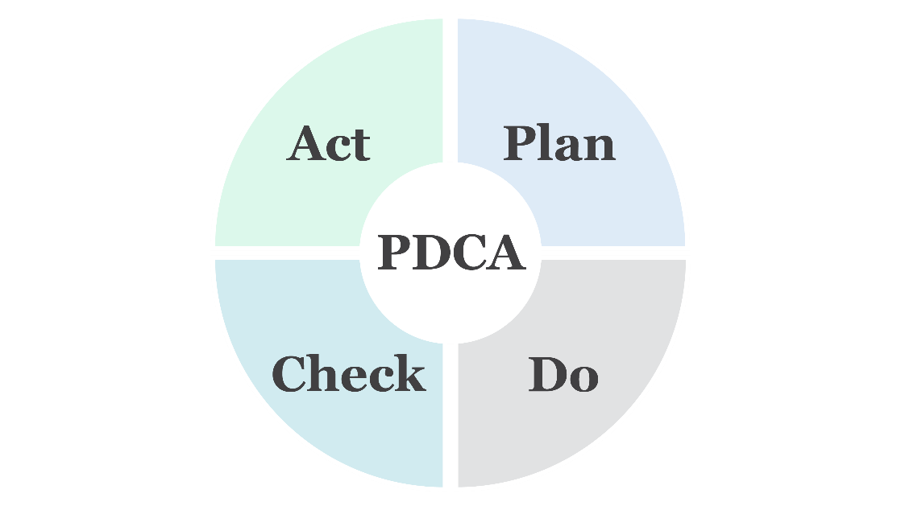
Jamal King |  | Sustainability Officer
Sasha Petrov |  | Office Manager
Problem Statement
Energy costs are high, and the company wants to lower its carbon footprint by reducing energy consumption.
Current State
1. Lights remain on during nonbusiness hours.
2. Energy-intensive equipment remains plugged in when not in use.
3. Employees leave devices running unnecessarily.
Plan
Goals
1. Reduce total energy consumption by 15% over the next six months.
2. Ensure that employees adopt energy-efficient habits, like turning off lights and unplugging devices when not in use.
Measures
1. Measure energy consumption through monthly utility bills and real-time energy monitoring.
2. Conduct employee surveys to track awareness and behavioral changes regarding energy-saving practices.
Proposed Solutions
1. Implement motion-sensor lighting in common areas.
2. Launch an internal campaign to raise employee awareness of energy conservation.
3. Set up automatic shutoff for computers and printers after a set period of inactivity.
Action Plan
Task | Owner |  | Start Date | End Date |  | Location / Test Population |  | Expected Outcomes
Install motion sensors in conference rooms, hallways, and bathrooms. | Henry McNeal |  | MM/DD/YY | MM/DD/YY |  | Corporate headquarters, 3rd and 4th floors |  | Energy usage will drop by at least 5% in the first month
Configure computer systems to automatically enter sleep mode after 15 minutes of inactivity. | Diana Kennedy |  |  |  |  | Corporate headquarters
Organize staff training on energy-saving habits and best practices. | Jamal King |  |  |  |  | All locations |  | Improving staff awareness should further reduce energy consumption within three months.

Do
Completed Actions and Data
1. Installed motion sensors in all conference rooms and bathrooms. Henry coordinated the installation with the facilities team.
2. Diana programmed all office computers to enter sleep mode after 15 minutes of inactivity, and printers to turn off after two hours of nonuse.
3. Jamal launched the “Save Energy, Save Money” campaign with flyers, emails, and a kickoff presentation to staff.
4. Collected initial data by comparing energy usage before and after implementation (November vs. December utility bills).
Check
What Worked?
1. Energy consumption dropped by 8% in the first month.
2. Employees responded well to the campaign; 70% reported turning off lights more often and being mindful of device use.
What Didn't Work?
1. IT systems failed to shut down printers as planned, requiring troubleshooting.
2. Motion sensors in some rooms were too sensitive, causing lights to turn off during use and frustrating employees.
Data Review
1. Monthly energy usage decreased from 10,000 kWh to 9,200 kWh in the first month, slightly below the 5% predicted drop.
2. Survey data showed increased awareness but indicated the need for better IT system adjustments.

Act
Adopt, Adapt, or Abandon the Changes?
1. Modify and retest: Adjust the sensitivity of motion sensors in high-traffic rooms and fix the auto-shutdown issue for printers.
2. Sustain the change: Continue the internal campaign with monthly reminders and add a leaderboard showing which departments save the most energy.
Next Steps
1. Reassess energy usage in two months after implementing these modifications.
2. Test new energy-efficient light bulbs in high-use areas and consider expanding the motion sensor setup to all office floors.

DISCLAIMER

Any articles, templates, or information provided by Smartsheet on the website are for reference only. While we strive to keep the information up to date and correct, we make no representations or warranties of any kind, express or implied, about the completeness, accuracy, reliability, suitability, or availability with respect to the website or the information, articles, templates, or related graphics contained on the website. Any reliance you place on such information is therefore strictly at your own risk.

