**](https://www.smartsheet.com/try-it?trp=12190&utm_source=template-word&utm_medium=content&utm_campaign=FOCUS+PDCA+Worksheet-word-12190&lpa=FOCUS+PDCA+Worksheet+word+12190)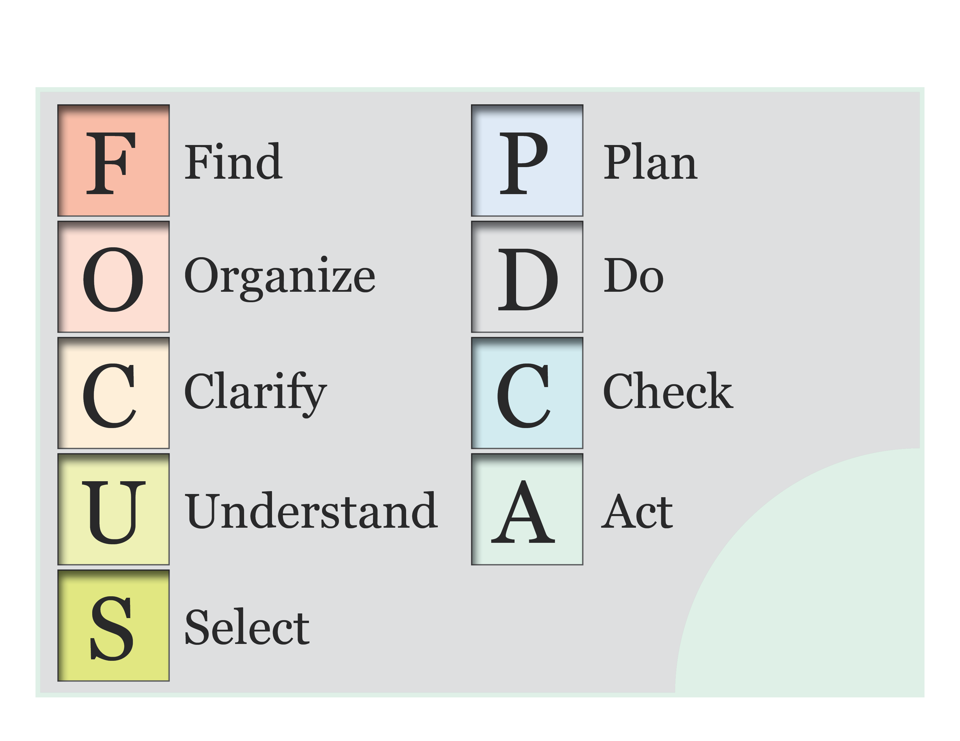FOCUS PDCA Worksheet Template**

|  |  |  |  |
| --- | --- | --- | --- |
| **F** | **Find a Problem or Improvement Opportunity** | | |
| *Study customer surveys, employee feedback, performance data, etc. to identify issues and create a prioritized list.* | | |
|  | | |
| **O** | **Organize a team** | | |
| **Name** | **Role** | **Contact Information** |
|  |  |  |
|  |  |  |
|  |  |  |
| **C** | **Clarify Current Knowledge of the Problem** | | |
| *After identifying a high-priority issue to focus on, write a clear problem statement. Attach a process map to illustrate the issue.* | | |
|  | | |
| **U** | **Understand the Root Causes** | | |
| *Gather information and conduct a root cause analysis. Attach any relevant tools, such as a fishbone diagram* | | |
|  | | |
| **S** | **Select an Improvement Strategy** | | |
| *Identify potential solutions and describe the rationale for each intervention.* | | |
|  | | |

|  |  |  |  |  |
| --- | --- | --- | --- | --- |
| P | **Plan the Improvement** | | | |
| *Define objectives, measures, and an action plan for implementing the improvements.* | | | |
| **Activities** | **Owners** | **Dates** | **Expected Impact** |
|  |  |  |  |
|  |  |  |  |
|  |  |  |  |
| D | **Implement the Plan** | | | |
| *Record observations, setbacks, and results.* | | | |
|  | | | |
| C | **Check the Results** | | | |
| *Evaluate the plan's effectiveness and determine whether adjustments are needed by comparing the results to predicted outcomes. Attach data reports or graphs to demonstrate your analysis.* | | | |
|  | | | |
| A | **Standardize the Change** | | | |
| *If the plan worked, standardize the intervention. If not, refine the intervention or select a new one to test.* | | | |
|  | | | |

|  |  |
| --- | --- |
| Next Steps | |
|  | |
| Lessons Learned | |
|  | |
| **DISCLAIMER**  Any articles, templates, or information provided by Smartsheet on the website are for reference only. While we strive to keep the information up to date and correct, we make no representations or warranties of any kind, express or implied, about the completeness, accuracy, reliability, suitability, or availability with respect to the website or the information, articles, templates, or related graphics contained on the website. Any reliance you place on such information is therefore strictly at your own risk. | |